|  |
| --- |
| Guide for  Reading Eligible Provider (EP) and Hospital Measures |
| December 2010 |
|  |



Contents

1. Introduction 3

2. Documents you will need 4

eMeasure specification (three files per measure) 4

Individual eMeasure code list (one file per measure - NQF_Retooled_Measure_*xxx*.xls ) 4

eMeasure code lists(two files, NQF_Retooled_Measure.xls, NQF_Retooled_Measure.csv) 4

3. Opening the documents 4

eMeasure specification (NQF_HQMF_HumanReadable_*xxx*. xml and HQMFreader.xsl) 4

eMeasure code lists(NQF_Retooled_Measure_*xxx*.xls) 5

4. Reviewing the documents 5

eMeasure specification(NQF_HQMF_HumanReadable_*xxx*.pdf) 5

Header 5

Population Criteria 7

Data Criteria (QDS Data Elements) 15

Summary Calculation 15

eMeasure code lists(NQF_Retooled_Measure_*xxx*.xls) 16

Basics 16

# Introduction

This document provides guidance for understanding and using the electronically specified measures identified as ‘retooled’ that were published as Eligible Provider (EP) and Hospital Measures in .xml and .html format.

Collecting and reporting accurate, comparative healthcare performance data is complex and largely a time consuming, manual process. Much of the information required for performance measurement is available in electronic health records (EHRs) but it has not been routinely available for export and use to compute measures. Performance measures most frequently address routinely available data and are therefore often based on claims and sometimes accessible laboratory results and pharmaceutical usage data (clinically enriched measures).

Truly accessing the rich clinical data residing in EHRs requires that measures are specified to account for the way data are expressed in EHRs. NQF, through the Health Information Technology Expert Panel (HITEP), established the Quality Data Set (QDS) to enable such expression of data requirements in the context of EHR usage. To further enable electronic measurement, NQF supported the development of an electronic standard based on the Quality Data Set (QDS) known as the eMeasure representation of the Health Quality Measure Format (HQMF). This electronic standard will allow EHR vendors to more directly manage information required for measurement in their products.

The Centers for Medicare and Medicaid Services (CMS) asked NQF to convert, or “retool,” a number of existing NQF-endorsed measures from a paper based format to an electronic eMeasure format so they can be more easily interpreted by EHRs. NQF worked with the original stewards of these measures to assure the intent and meaning is preserved and to avoid substantive change that would require re-evaluation of evidence and intent. This project was specifically scoped to redefine the measures ‘as is,’ but in the context of EHR data. The initial versions of these measures were published in July 2010 in PDF, human readable format while the current versions, being released early 2011, are published in full HQMF format. This guide should assist the reader in interpreting and better understanding the content.

The retooling process involves many complex steps and key stakeholder involvement. Specifically, measure retooling consists of measure developers evaluating each selected measure and applying the QDS to each data element. This process also includes creating or updating code lists using standard terminologies and applying these code lists to QDS data types. The resulting quality data elements are then configured to address the logic and to express the measure algorithm. This protocol is performed using a ‘prototype’ authoring tool, created by NQF staff, for this project. In November 2010, NQF contracted with an external vendor to implement and launch a fully tested web-based authoring tool that will be implemented and available for use in mid 2011. This tool will enable measure developers to directly author measures using the QDS and avoid the need for retooling.

# Documents you will need

Each measure folder contains **four** files that are necessary to understand the electronic measure.

eMeasure specification (three files per measure)

The eMeasure specification is provided in two formats:

* The HQMF standard .xml format (NQF_HQMF_HumanReadable_*xxx*.xml) with a related file, a *style sheet* that allows the .xml format to open directly in a web browser (HQMFreader.xsl)

**AND**

* The HQMF human readable format in **html** to open directly in a web browser (NQF_HQMF_HumanReadable_*xxx*.html)

The HQMF file contains the eMeasure specifications including measure background information, the required data elements, measure logic, and measure calculation instructions. This file is using the eMeasure Health Quality Measure Format (HQMF).

Individual eMeasure code list (one file per measure - NQF_Retooled_Measure_*xxx*.xls)

This file contains an Excel spreadsheet with the code lists used for the respective measure. The code lists also contain code descriptors for all taxonomies except CPT.

eMeasure code lists(three file format options)

These files contain all of the code lists (a synonym for value sets) referenced by all QDS data elements in all of the eMeasures in the set. The code lists also contain code descriptors for all taxonomies except CPT. File format options are as follows: NQF_Retooled_Measure.xls (Part1 and Part2, Microsoft Excel 97-2003 Worksheet), NQF_Retooled_Measure.xlsx (2007 compatible), NQF_Retooled_Measure.csv.

# Opening the documents

eMeasure specification (NQF_HQMF_HumanReadable_*xxx*. xml and HQMFreader.xsl)

1. To view the xml structure: The HQMF standard .xml format can be opened using an XML editor program or can be viewed in any text editor (e.g., Note Pad). To open in a text editor, right click on the file and select “Open with,” then select the text editor of your choice.
2. To view the human readable format in a web browser:
   1. Double click on the .xml file to open in human readable format in a browser such as Internet Explorer or Firefox. This step will *only* work if the HQMFreader.xsl file (called a style sheet) provided with the measure is located in the **same** folder on your computer as the .xml file. Please note that not all browsers behave the same way with .xml style sheets. Note, the identical HQMFreader.xsl style sheet is provided with each HQMF.
   2. The HQMF is also provided in .html format. Double click on the .html file to open the measure in human readable format in a browser such as Internet Explorer or Firefox. This step will work *without* the HQMFreader.xsl file mentioned above.

eMeasure code lists(NQF_Retooled_Measure_*xxx*.xls)

To view the code lists, codes, and descriptors, you may open this Excel spreadsheet in any spreadsheet reader that understands Excel, such as Microsoft Excel or Open Office. Note, the file containing all code lists for all of the measures is quite large. It will require version 2003 or higher version of Excel to display all codes. A .csv file is also provided that can be opened in a program that can handle large amounts of data.

# Reviewing the documents

eMeasure specification(NQF_HQMF_HumanReadable_*xxx*.pdf)

The human readable eMeasure contains four main sections: header, population criteria, data criteria, and summary calculation.

### Header

The header, (refer to Figure 1 below) contains pertinent information about the measure and includes the following components:

1. eMeasure name – represents the title of the particular quality measure.
2. eMeasure Id – unique measure identifier for a particular version of a quality measure.
3. Version number – a number used to version successive replacement documents.
4. Set Id – unique measure identifier for each quality measure regardless of version available date .
5. Available Date – represents the time that a particular completed version of an eMeasure was made publically available.
6. Measurement period – represents the time interval for the performance calculation. This time range is **not** the same as the reporting period. A reporting period is the time interval over which data for the measure is collected. The same measure may have different reporting periods.
7. Measure steward – the organization responsible for the measure content and maintenance.
8. Endorsed by – the organization that has taken the measure through a consensus process for endorsement.
9. Description – a general description of the measure intent.
10. Copyright – identifies the organization(s) who own the intellectual property represented by the measure. The owner of the measure has the exclusive right to print, distribute, and copy the work. Permission must be obtained by anyone else to reuse the work in these ways.
11. Measure scoring – indicates how the calculation is performed for the measure (e.g., proportion, continuous variable, ratio, etc.).
12. Measure type – indicates whether the measure is used to examine a process or an outcome over time (i.e., structural, process, or outcome measure).
13. Stratification –present in some measures to provide information on how the measure’s population can be compared within categories or strata defined by one or more characteristics such as age, ethnicity, etc. (e.g., all patients 18-64 or all patients 65 and above).
14. Risk Adjustment – present in some measures to account for differences among a population’s characteristics (i.e. clinical, demographic) when evaluating the processes or outcomes of the measure.
15. Data aggregation – indicates how data will be analyzed and statistically reported for quality improvement and public reporting activities.
16. Rationale – a general description of the evidence used by the expert panel that created the measure to develop the logic.
17. Clinical recommendation statement – general advice regarding the measure and its content developed by the expert panel that created the measure.
18. Improvement notation – indicates whether an increase or decrease in the score is the preferred outcome of the measure (i.e., higher score indicates better quality).
19. Measurement duration – indicates the length of time covered by the measure (e.g., 12 months).
20. Reference – identifies bibliographic citations or references to clinical practice guidelines, sources of evidence, or other relevant materials supporting the intent and rationale of the measure.
21. Definition – description of individual terms, provided as needed.
22. Guidance – present in some measures to provide the user with important information on how to interpret or implement certain components of the measure. When implementing the measure, refer to this guidance section, where present, for additional information about the data elements, logic, and timing of the measure’s specifications.

Figure 1. The figure below is example with headers displayed shows retooled EP Measure 0519, Diabetic Foot Care and Patient/Caregiver Education Implemented During Short Term Episodes of Care (measure developer, Acumen). eMeasure name, eMeasure Id, version number, set Id, available date, measurement period, measure steward, endorsed by, description, copyright, measure scoring, measure type, stratification, risk adjustment, data aggregation, rationale, clinical recommendation statement, improvement notation, measurement duration, reference, and guidance (each defined in the text).

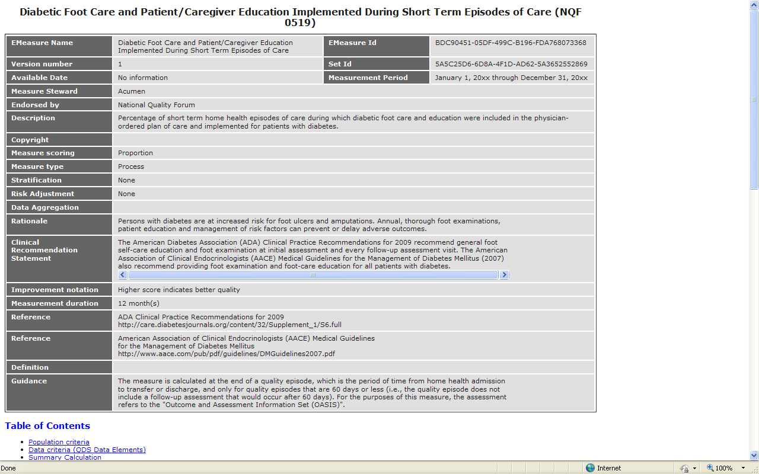

### Population Criteria

This section contains the four main components of the population criteria for a measure: initial patient population, denominator, numerator, and exclusions (see Figure 2). Each component contains measure elements that are joined together with OR, AND, and NOT. Each measure element or statement also includes one or more QDS data elements and information about how these elements compare to others. For example, in Figure 2 below, the patient population contains a QDS data element (“Patient characteristic: birth date”) and additional comparison logic (“>=41 year(s) and <= 68 year(s)”).

The Population Criteria section further describes how to calculate age using the birth date as compared to a unit of time or in comparison to another data element (e.g., *start before start of* “*measurement period*”). This should be read as, “all patients with birth dates that start before measurement period by at least 41 years and less than or equal to 68 years” – i.e. patients >=41 and <=68 years old before the first day of the measurement period. Note that a number of measures require stratification by age groups or by procedures performed. Each stratum is defined as a distinct population. Therefore, in stratified measures, there are multiple populations (e.g., Population 1, Population 2…). Each population contains an initial patient population, a denominator, one or more numerators, and an exclusion section as defined below. Each population is also calculated separately.

Definitions of Population Criteria elements:

1. Initial Patient Population – individuals for whom measurement is intended. Note, most of the previous discussion suggested patients as the focus of measurement. Some measures are focused on events, such as encounters or procedures (e.g., all inpatient discharges, all hemodialysis treatments, all imaging procedures).
2. Denominator – individuals or events for which the expected process and/or outcome should occur (in some cases the denominator is equivalent to the population). The denominator is calculated by adding all that meet denominator criteria.
3. Numerator – interventions and/or outcomes expected for the individuals or events identified in the denominator and population. The performance calculation is the number meeting numerator criteria divided by the final denominator. For measures with multiple numerators, calculate each numerator separately within each population.
4. Exclusions – individual characteristics that cause the expected process and/or outcome to be inappropriate for an individual or events specified in the denominator and initial population. Exclusions are calculated for all patients who meet population and denominator criteria and who do not meet numerator criteria. Measures with multiple numerators apply the same exclusions to each numerator.

Components of Population Criteria elements:

1. Logical Operators – AND, OR, NOT are used to connect or create relationships between elements or statements in a measure.
   1. The AND operator means all elements joined by the AND are present for consideration by the measure.
   2. The OR operator means any one elements may be present for consideration by the measure.

**EXAMPLE:**

* **Initial Patient Population =**
  + AND: "Instance A of Encounter: Home Health (duration <= 60 days)" during "Measurement period"
  + AND:
    - OR:
      * AND: "Instance A of Encounter: Home Health" during "Measurement period"
      * ends after start of "Diagnosis active: Diabetes"
    - OR:
      * AND: "Procedure order: Diabetic Foot Care"
      * AND: "Intervention order: Diabetic Foot Care Education"
      * during ("Instance A of Encounter: Home Health" during "Measurement period")
  + AND:
    - OR: "Instance A of Encounter: Home Health (status: 'discharged')" during "Measurement period"
    - OR: "Instance A of Encounter: Hospital Stay (duration >= 24 hours)" starts after end of ("Instance A of Encounter: Home Health" during "Measurement period")

In an example taken from EP Measure 0519, Diabetic Foot Care and Patient/Caregiver Education Implemented During Short Term Episodes of Care (measure developer, Acumen), is used to explain the use of AND and OR operators. The AND operator requires that the statement following it is true. In this case:

1. the home health encounters must span a duration of <= 60 days during the measurement period,
2. *and* either (*or*) the home health encounters must not end until after the diagnosis of diabetes has been determined (*or)* that an order for diabetic foot care *and* an order for diabetic foot care education is complete
3. *and* either (*or*) the home health encounter ended (‘discharged’) during the measurement period, (*or*) the patient was hospitalized for a stay >24 hours after a home health encounter that occurred during the measurement period.

* 1. The NOT operator means that one to many elements are excluded from consideration by the measure. (e.g., xxxx)

**EXAMPLE:**

* **Denominator=**
  + AND: NOT "Instance B of Procedure performed: Hospital Measures - Joint Commission Evidence of a surgical procedure requiring general or neuraxial anesthesia" <= 4 day starts before start of "Instance A of Procedure performed: Hospital Measures - CABG (incision)"
  + AND: NOT "Instance B of Procedure performed: Hospital Measures - Joint Commission Evidence of a surgical procedure requiring general or neuraxial anesthesia" <= 4 day starts after end of "Instance A of Procedure performed: Hospital Measures - CABG (incision)"

In an example taken from Hospital Measure 00527 (Prophylactic Antibiotic Received Within One Hour Prior to Surgical Incision; Oklahoma Foundation for Medical Quality) an excerpt from the denominator is shown. The index procedure (CABG) is identified as Instance A. The measure logic is written to exclude (AND NOT) an unrelated procedure. In this case any major surgical procedure requiring general or neuraxial anesthesia that occurs within 4 days before or after the index CABG procedure (Instance A) causes the patient to be excluded from the denominator. Therefore, general or neuraxial anesthesia is listed as Instance B to differentiate it from the anesthesia that occurred in conjunction with the index CABG procedure.

1. Data Element Interrelationships – defines specific relationships between two or more data elements (e.g., element A starts before the start of element B) or periods of time (e.g., element A <= 12 months starts before the start of element B). Multiple relationships between data elements are found in each measure. Fifteen relationships are used to associate one data element with another in the retooled measures as listed below. The timing of some relationships is self-explanatory (e.g., A *during* B); others require more definition. When detail about allowable timing is required, the acceptable time difference is listed before the relationship statement (e.g., A <= 10 months *starts before start of* B). If no timing is specified (e.g., A *starts before the start of* B) the statement indicates there is no time limit (e.g., A starts before the start of B means A can occur *anytime* before B starts).
   * + ends after end of
     + ends after start of
     + ends during
     + ends before or during
     + ends before start of
     + ends concurrent with
     + starts after end of
     + starts after start of
     + starts during
     + starts before or during
     + starts before start of
     + starts concurrent with
     + concurrent with
     + occurs during
     + overlaps with
2. Parentheses - Multiple phrases may be joined in one logic statement by a series of relationship types (i.e. starts before the start of) and timeframes (i.e.<=10 months).  Parentheses are used to clarify which elements, timing type, and timeframe belong to which phrase, similar to how parentheses are used in mathematical equations.  As a result, at the end of one statement you may see one or more parenthesis.  Careful examination of the statement will reveal the nested phrases and timing relationship that the parenthesis belongs to.  In the example provided above:

"Procedure order: Diabetic Foot Care” and “Intervention order: Diabetic Foot Care Education” are both expected to happen during (“Instance A of Encounter: Home Health” during the “Measurement Period”). Parentheses are added to clarify the relationship to the reader of the orders (A and B) that must occur during an (encounter (C) that must be during the measurement period (D)), hence in simple mathematical logic:

A + B during (C during D)

1. Indentation - In general, indents are used to show items that are grouped together. The relationship statement at the end of a series of items indented at the same level applies to all elements in the series. The subsection of the example from above shows that the during ("Instance A of Encounter: Home Health" during "Measurement period") at the end of the series, applies equally to both “Procedure order: Diabetic Foot Care” and the “Intervention Order: Diabetic Foot Care Education.”

OR:

* + - * AND: "Procedure order: Diabetic Foot Care"
      * AND: "Intervention order: Diabetic Foot Care Education"
    - during ("Instance A of Encounter: Home Health" during "Measurement period")

1. Instance of an Element - A QDS element can be referenced several times in a measure and represent one to many episodes or instances of that element. To differentiate to the reader if each episode of that element is the same as or different from a prior episode referenced elsewhere in the measure, a label of “Instance” will be placed before the element. The concept of an instance of an element is employed as follows:
   1. If a QDS element is reused multiple times in the measure and the measure means to use the same Instance of that element, the element will be referred to as Instance X of element, i.e. Instance A of the element. For example, Instance A of encounter inpatient.
   2. If that same QDS element is used again in the measure and references another specific instance of that same element it is referred to as Instance B of the element. For example, Instance B of encounter inpatient.
   3. If that same QDS element is used again in the measure but references no specific Instance of that same element, it is referred to as Any Instance of the element. For example, Any Instance of encounter inpatient
2. Data Attributes – characteristics of data elements that help specify more precisely what information is required to determine adherence to the measure criteria. There were 30 attributes identified during the course of retooling the set of EP and Hospital Measures. Each attribute is defined in the following table:

| **Attribute** | **Description / Examples** |
| --- | --- |
| Admission | Start time for inpatient admissions |
| anatomical structure | An anatomical body part (e.g., foot) |
| Arrival | The time the patient presents to the location. In this measure set, for hospital admissions, the arrival time is the start time assigned to a location in the hospital; the location is an attribute of the encounter. Also in this measure set, for emergency department encounters, the start time is the arrival time. |
| cumulative medication duration | The total number of days of medication required to comply with the measure criteria. |
| date is present | A date exists. |
| Discharge | The end time for inpatient admissions. |
| discharge status | The disposition of the patient at the time of discharge (generally used in the existing measure set to express exclusions, e.g., left against medical advice, expired) |
| End time | The time the related data element ends. |
| environment | The setting in which an action or event takes place (e.g., home, school, work, etc.) |
| health record | The location where the data element is expected to be found – in the context of the existing measure set this attribute is used to describe the “health record” location of “discharge medication list.” |
| Incision time | The time of a surgical incision related to the relevant surgical procedure. |
| Insertion time | The time a device is inserted (also the start time for the device with respect to the measure). |
| is present | Exists, generally used to describe that a result should be present even if the measure doesn’t specify what result is needed. |
| facility location | The healthcare setting in which an encounter occurs; e.g., ICU, or non-ICU. |
| Laterality | The side (left or right) of an anatomical structure. |
| Ordinality | The order in which an element is expected; e.g., “principal” diagnosis or procedure for an inpatient admission. |
| radiation dosage | The total dosage of radiation received during a procedure or diagnostic test; e.g., fluoroscopy. |
| radiation duration | The elapsed time (duration) of radiation exposure during a procedure or diagnostic test; e.g., fluoroscopy. |
| Reason | The documented purpose for performing an action (or for not performing an action. |
| reason for delay is not present | The documented reason for not performing an action in the expected time frame is not provided; the attribute is used in the exclusion section of several inpatient measures. |
| reason is not present | The documented reason for not performing an action is not provided; the attribute is used in the exclusion section of several inpatient measures. |
| reason is present | The documented reason for performing an action or for a delay in performing the action; the attribute is used in the exclusion section of several inpatient measures. |
| Removaltime | The time a device is removed (also the end time for the device). |
| Result | The findings determined by a laboratory test, diagnostic test, procedure or physical examination. |
| result is present | Evidence findings determined by a laboratory test, diagnostic test, procedure or physical examination are present; any result is acceptable. |
| result value | The findings determined by a laboratory test, diagnostic test, procedure or physical examination with the required value specified; the value can be a numerical value (e.g., LDL < 100 mg/dL) or a finding (e.g., an EKG finding of “left bundle branch block). |
| Route | The method by which a medication or substance is administered; e.g., IV, IM or orally. |
| Severity | The intensity of illness required to be criteria for the data element; the severity attribute is always followed by a specific definition (e.g., persistent, moderate, or severe). |
| Source | The originator of the information; e.g., the source of the ECG reading is a physician. |
| Status | The state of a data element, e.g., final report, on hold (medication), discontinued (medication), discharged, |

1. Additional Logic Relationships:
   1. counts of events (e.g. count of procedures > = 1),
   2. first and last occurrences of an event, and
   3. maximum or minimum results.

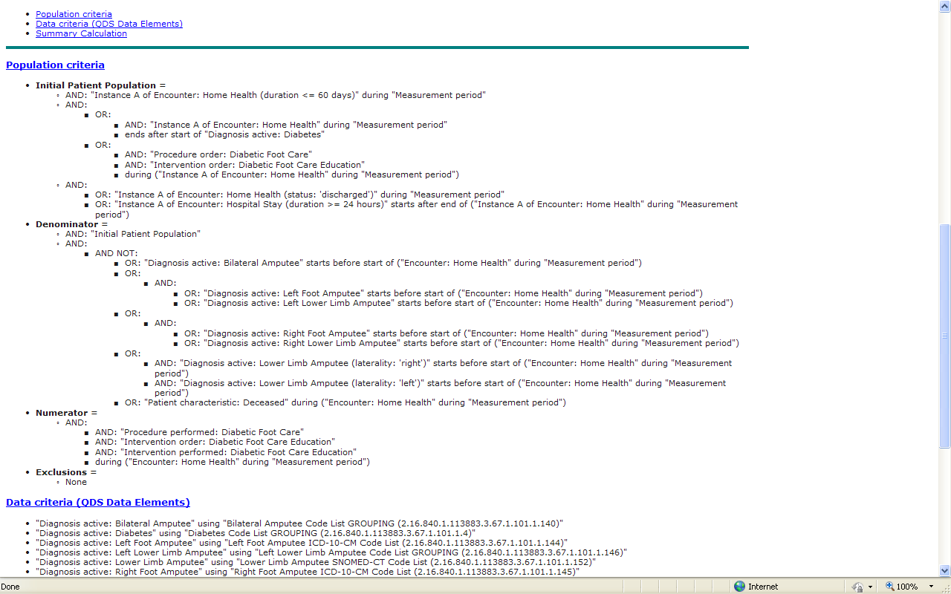

Figure 2. Sample from eMeasure population criteria: containing population, denominator, numerator and exclusion criteria and related logic. More specific information about each is included in the text. The complete logic for EP Measure 0519, Diabetic Foot Care and Patient/Caregiver Education Implemented During Short Term Episodes of Care (measure developer, Acumen).measure is shown as an example.

### Data Criteria (QDS Data Elements)

This section covers QDS data element requirements from the population criteria. Each element is composed of a QDS data type (“Diagnostic study performed,” “Procedure performed,” etc.) and refers to a code list, also called a “value set.” Each code list can be identified by its name.

For the individual list of codes that are contained in this code list (also known as a value set), please refer to the eMeasure code list spreadsheet (see below).

Examples: 1) A QDS data element of QDS data type “Diagnostic study **performed**” refers to a code list with a standard category of “Diagnostic study.” 2) QDS data element of QDS data type “Procedure **performed**” refers to a code list with a standard category of “Procedure.” The QDS data type is used to identify the location of the electronic information for the measure. The code list identifies what codes should be searched within that location.

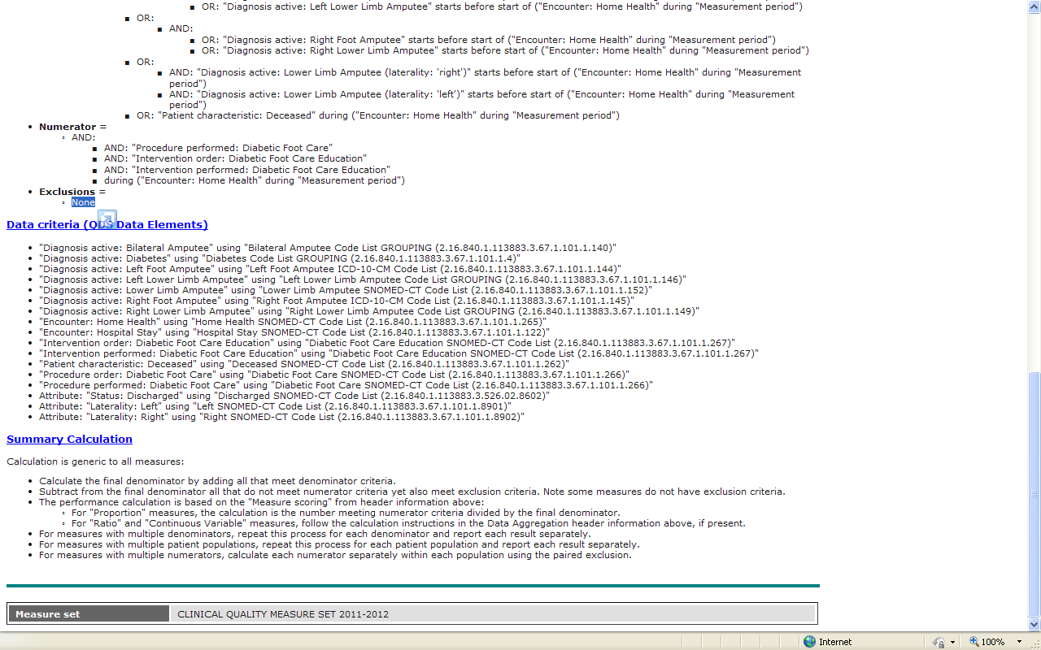

Figure 3. Sample from eMeasure data criteria section. The data elements and code list identifiers (OIDs) are listed for EP Measure 0519, Diabetic Foot Care and Patient/Caregiver Education Implemented During Short Term Episodes of Care (measure developer, Acumen).

### Summary Calculation

The measure components (initial population, numerator, denominator, and exclusions) are processed according to the algorithm listed in this section to calculate the result of the measure.

Please refer to this section for the appropriate calculation instructions.

Calculation is generic to all measures:

* Calculate the final denominator by adding all that meet denominator criteria.
* Subtract from the final denominator all that do not meet numerator criteria yet also meet exclusion criteria. Note some measures do not have exclusion criteria.
  + For proportion measures the calculation is the number meeting numerator criteria divided by the final denominator. The performance calculation is based on the Measure Scoring from the header information
  + .For Ratio measures follow the calculation instructions in the Data Aggregation header e.g. ratio, continuous variable
* For measures with multiple patient populations, repeat this process for each patient population and report each result separately.
* For measures with multiple numerators, calculate each numerator separately within each population using the paired exclusion.

eMeasure code lists(NQF_Retooled_Measure_*xxx*.xls)

### Basics

All codes for eMeasures are identified in a spreadsheet for that measure. The spreadsheet also contains 11 columns; each with information about the individual code lists (value sets). Table 1, below, provides a description of the information in each column.

Groupings are code lists (value sets) that have nested within them other value sets. Groupings are used for two reasons:

1. To combine value sets for the same concept, each in different taxonomies (e.g., ICD9, ICD10, SNOMED)
2. To combine objects that can be used independently but for the specific data element are used together (e.g., encounters may include ‘encounter ambulatory,’ encounters inpatient,’ encounters behavioral health,’ may each be used individually for some elements of a measure wile in other measures any encounters 9in any of those encounters apply). This type of grouping is a convenience grouping to avoid the need to create an additional value set (e.g., “all encounters”) or to provide more lengthy logic descriptions.

| Table 1. eMeasure Code List Spreadsheet Elements **(NQF_Retooled_Measure_*xxx*.xls)** | |
| --- | --- |
| **Column Name** | **Description** |
| Measure developer | The measure steward; the organization responsible for the measure content and maintenance |
| standard OID | A unique identification number for the code list |
| standard concept | A descriptive name for standard concept, most often defined by a specific code list – the standard concept *plus* the QDS data type comprise the QDS data element  *(e.g., diabetes, inhaled corticosteroids, pregnancy test)* |
| standard category | Descriptive name for the QDS data type with which the standard element is used |
| standard taxonomy | The medical coding system, or taxonomy, used to describe the standard concept *(e.g., ICD-9, RxNorm, LOINC).* In some cases the code list (value set) is a ‘superset,’ in that it is a combination of other code lists (value sets) in the spreadsheet. These ‘supersets’ are called *GROUPINGs*. The taxonomies used are specified with the individual code lists listed in the grouping. |
| standard taxonomy version | The version of the coding system, or taxonomy used to describe the standard concept |
| code | The code included within the code list (value set). If the standard taxonomy column indicates *GROUPING*, the standard OID (identifier) of each individual code lists in the *GROUPING* is listed in this section rather than individual codes.  *GROUPINGs* that combine code lists for the same concept in different taxonomies display a standard OIDs for each of the respective concepts. Some concepts could not be expressed in certain taxonomies, or the measure developer preferred to limit the taxonomies provided. Therefore, all *GROUPINGs* do not include all taxonomies expected. |
| descriptor | The text description for each code. Note that descriptors are provided for all codes except those derived from Current Procedural Terminology (CPT®). CPT® contained in the Measure specifications is copyright 2004- 2010 American Medical Association. |